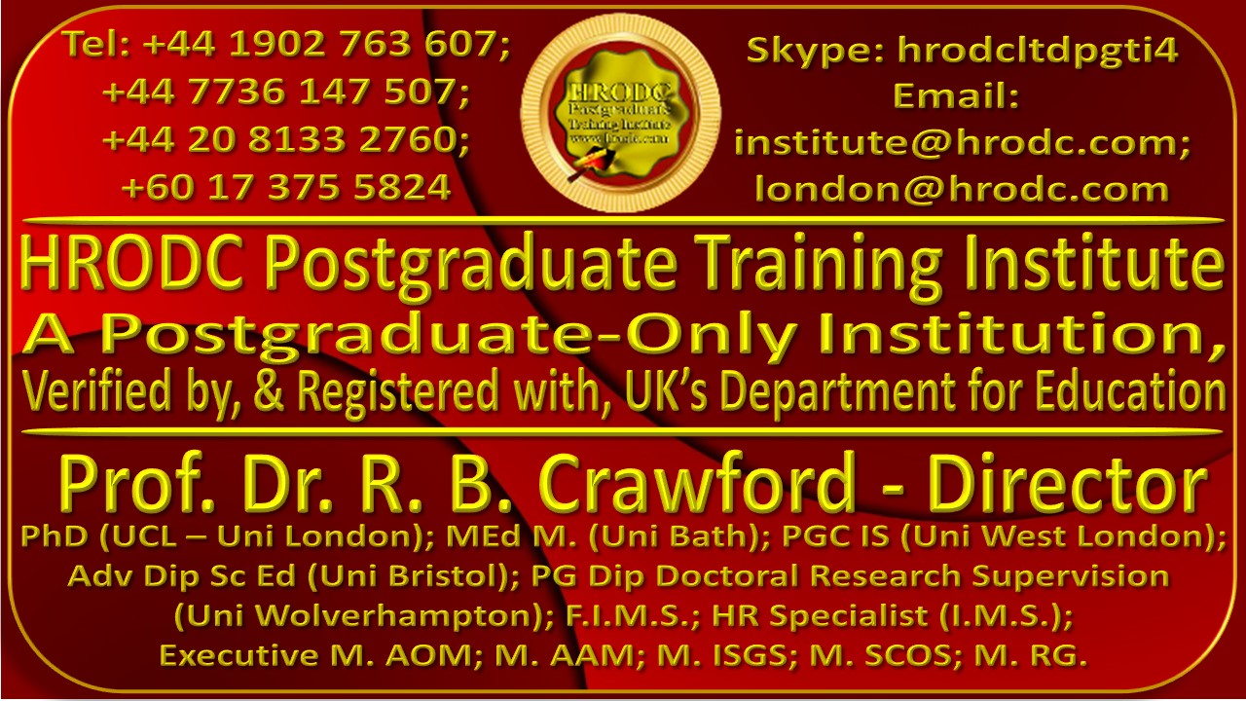
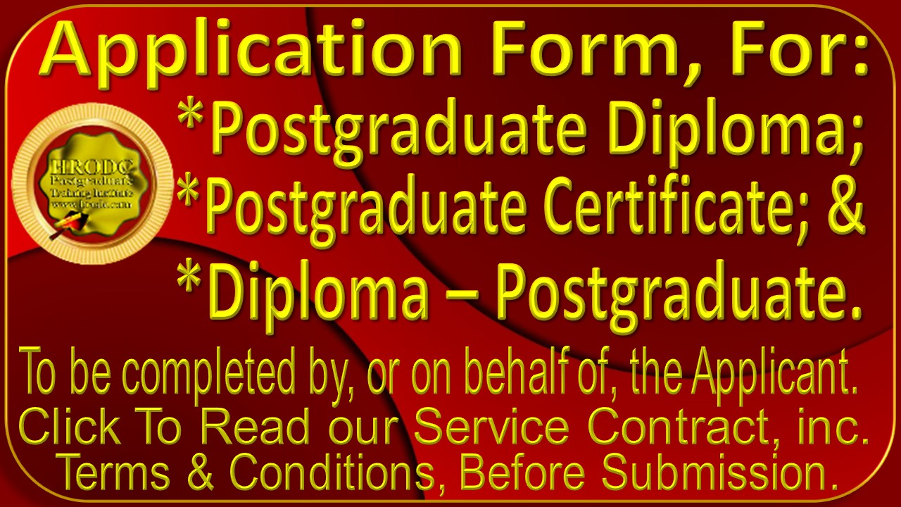

Please Affix a Recent Picture of Applicant - here

General Information
(Please Print)
Surname/Family Name | First Name & Other Names |  | Title (Dr. Prof. Mrs. Mr. etc)
Date of Birth (DD/MM/YYYY) | Gender (Male/Female) |  | Nationality
Permanent Address
Temporary Address
Home Telephone Number | Mobile Number |  | Private E-mail Address
Work Address
Work Telephone Number | Work Fax Number |  | Work E-mail Address
Name of Employer |  | Position Held
Address of Employer
Name and Address of Sponsor (if not self-sponsored):

Course or Courses for Which You Are Seeking Admission
Course Number | Course Name | Location | Duration | Dates

NAME FORMAT FOR DIPLOMA ISSUANCE
Please Write your Names, below, in the precise order, spelling and format that you would like them to appear on your Diploma. Abbreviations should be used, where possible, to facilitate their bold appearance.

Chronological Education: College/ University
In the spaces below, please enter, in chronological order, all relevant details pertaining to the Colleges and, or, Universities that you attended. Please add as many rows as you require.
Dates –  From to (Month/Year) | Name and Address of Institution | Program Course/s Studied | Subjects/ Modules Taken | Award/ Qualification Gained

Non-Award Bearing Courses That You Have Taken
Please give details, below, of any non-award-bearing courses that you may have taken.
Name of Course | Name and Address of Organising Body | Course Duration | Dates  Date/Month/Year

Work Experience
Dates  (Date/Month/Year) | Name and Address of Employer | Position Held | Duties & Responsibilities

Your English Proficiency
(To be completed by Non-native English-speakers only)
If English is not your native language, HRODC requires evidence of your level of proficiency in spoken and written English. If you do not already hold an acceptable qualification in English (e.g. IELTS or TOEFL), you may be required to obtain one before you can be admitted to HRODC Postgraduate Courses.
Type of Test | Overall Score | Reading | Writing | Speaking | Listening
IELTS
TOEFL
Cambridge Tests
Other English Language
Qualification

Additional Information
Please provide us with any additional information, in the space provided below – using additional sheets, if necessary - that might support your application.

Details of Referees
Please provide us with the contact details of 2 referees, one of whom should be a trainer or academic and the other your manager or supervisor. Character References or Testimonials are not needed.
Description | Referee #1 | Referee #2
Name of Referee:
Referee’s Organisation:
Address of Referee:
Referee Contact Numbers:
Referee Email Address:
Relationship with Referee (e.g. Tutor, Manager, Trainer):

Promotional Monitoring
Kindly help us to monitor our promotional effort, by indicating your source of information about HRODC Courses. Please tick the appropriate column.
- HRODC Website |  |  |  |  | - My Training Manager
- My Colleague |  |  |  |  | - UK Department for Education & Skills
- News Paper Advert  Name of Paper: _______________ |  |  |  |  | - HRODC Course Brochure
- Another Website |  |  |  |  | - Another Member of my Organisation
- My Line Manager |  |  |  |  | - British Council
- My Workplace Information Bulletin |  |  |  |  | - Others: ___________________
- Direct Mailing by HRODC
Special Needs
In an effort to promote exclusivity, we would appreciate it if you would indicate the type of special needs that you might have, ticking the appropriate column, in you have none.
- Blind or partially sighted |  |  |  |  | - Mental Health difficulties
- Deaf or hearing impaired |  |  |  |  | - No special needs
- Need for personal care support |  |  |  |  | - Other special needs (please specify)  _____________________
Equal Opportunities and Diversity Monitoring
In line with our Equal Opportunities and Diversity Policies, we seek to monitor the variety of our intake. We would appreciate if you might tick the appropriate column, below, that best describes your ethnicity. The categories are in accordance with the UK census. If you would not like to reveal your ethnicity, please tick the last option.
- Asian or Asian British |  | - Black or Black British |  | - Mixed |  |  | - White
- Indian |  | - Caribbean |  | - White and Black Caribbean |  |  | - British
- Pakistani |  | - African |  | - White and Black African |  |  | - Irish
- Bangladeshi |  | - White and Asian |  | - Scottish |  |  | - Chinese
- Other White background |  | - Other Ethnic background |  | - I would prefer not to supply this information

HRODC Postgraduate Training Institute’s Polo Shirt Details
- At the Beginning and End of each Postgraduate Diploma Programme (3Months Intensive or 6 Months Full-Time or Double Postgraduate Diploma Programme (6 Months Intensive Full-Time and 1 Year Full-Time) each student will receive a Complimentary Institute Polo Shirt.

- Delegates attending Diploma – Postgraduate (Short) Courses will receive a Complimentary Institute Polo Shirt, at the end of their course.

- Kindly complete the sections below, to ensure the best chance of getting your preferred Institute Polo Shirt colour and size. You may select more than one colour, in the event that your preferred choice is unavailable.

- Additional Polo Shirts may be purchased at a modest cost.

- Please see Size Conversion Chart and Picture of Polo Shirt, below!

Please Choose Your Polo Shirt Colour, Below
The Available Sizes for each colour are in brackets ‘()’, under each corresponding colour.
Red | Sky blue | Black | Blue | White | Green

Please Choose your Polo Shirt Size Below
4XL | S | M | L | XL | XXL | XXL

Men’s Shirt Sizes | Women’s Shirt Sizes
Size Chest Neck  S 36 14-14.5  M 38-40 15-15.5  L 42-44 16-16.5  XL 46-48 17-17.5  XXL 50-52 18-18.5  3XL 54-56 19-19.5  4XL 58-60 20-20.5 | Size Numeric Size Chest  XS 4 32.5  S 6/8 35  M 10/12 37.5  L 14/16 40.5  XL 18/20 43.5  2XL 22/24 46.5

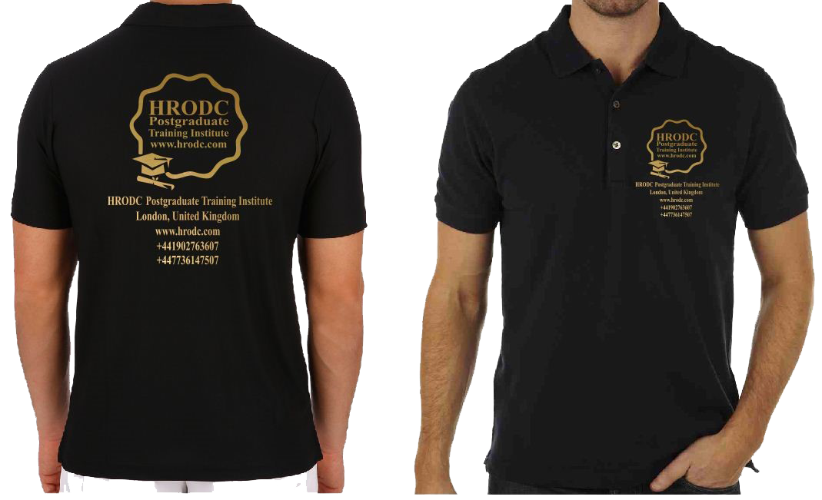
Here is the Actual Polo Shirt Design:

Final Declaration
Kindly read and sign the declaration, below, making correction to any aspect of the information that precedes it, before submitting this form.
Declaration
I hereby certify that the information that I have provided on this form is accurate and that I have not knowingly been deceptive. I am aware that any offer of a place on HRODC Postgraduate Training Institute’s Postgraduate Programmes and Short Courses that I may receive, will be based on the information that I have provided hereon, and that if I am found to have given false information, the offer of a place on the Programme or Course/s being applied for, may be withdrawn.

I am aware that the information supplied on this form will be retained by this Institute and will be used for the purpose of processing my application. Also, if my application is successful the information will form part of my student/delegate record.
Date: __________________________
Signature:

______________________________________________________

